Q1
class WordBuffer {
private:
char** words;
char* rawstr;
int* freq;
int wordcount;
int length(char* str) {
int i = 0;
while (str[i] != '\0') i++;
return i;
}
int length(const char* str) {
int i = 0;
while (str[i] != '\0') i++;
return i;
}
int lengthunique(char* str) {
int i = 0;
while (str[i] != '\0') {
if (str[i] == ',' || str[i] == '.') continue;
i++;
}
return i;
}
public:
WordBuffer() {
wordcount = 0;
}
void processSentence(char* input) {
rawstr = input;
words = new char* [getWordCount()];
int offset = 0;
for (int count = 0; count < wordcount; count++) {
words[wordcount] = new char[length(input)-offset];
int j = 0;
for (int i = offset; i < length(input);i++) {
if (input[i] == ',' || input[i] == '.') continue;
words[wordcount][j] = input[i];
j++;
}
offset += length(input);
}
}
int getWordCount() {
int i = 0;
if (*rawstr == '\0') return wordcount;
wordcount++;
while (rawstr[i] != '\0') {
if (rawstr[i] == ' ') wordcount++;
i++;
}
return wordcount;
}
const char* getWord(int n) {
return words[n];
}
int getFrequency(int x) {
return 1;
}
};

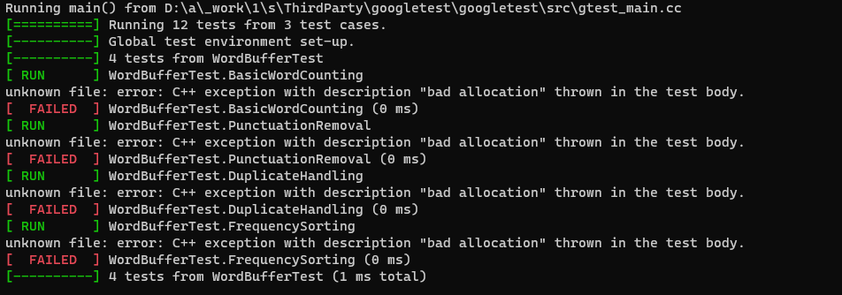
Q2
class PatternGenerator {
private:
int size;
int** arr;
public:
PatternGenerator() {
size = 27;
arr = new int* [size];
for (int i = 0; i < size; i++) {
arr[i] = new int[size];
for (int j = 0; j < size; j++)
arr[i][j] = ' ';
}
}
~PatternGenerator() {
for (int i = 0; i < size; i++)
delete[] arr[i];
delete[] arr;
}

void generate(int r = 27, int c = 27, int size = 27) {

if (size == 1) {
arr[r-1][c-1] = '#';
return;
}
size /= 3;
generate(r / size, c / size, size);
generate(r / size, c / size+size, size);
//generate(r / size+size, c / 3, size);
//generate(r, c / 3, size / 3);
//generate(r, 2 * c / 3, size / 3);
//generate(2 * r / 3, c, size / 3);
//generate(r, c, size / 3);
//generate(r / 3, c, size / 3);
}

char getCell(int r, int c) {
return arr[r][c];
}
};
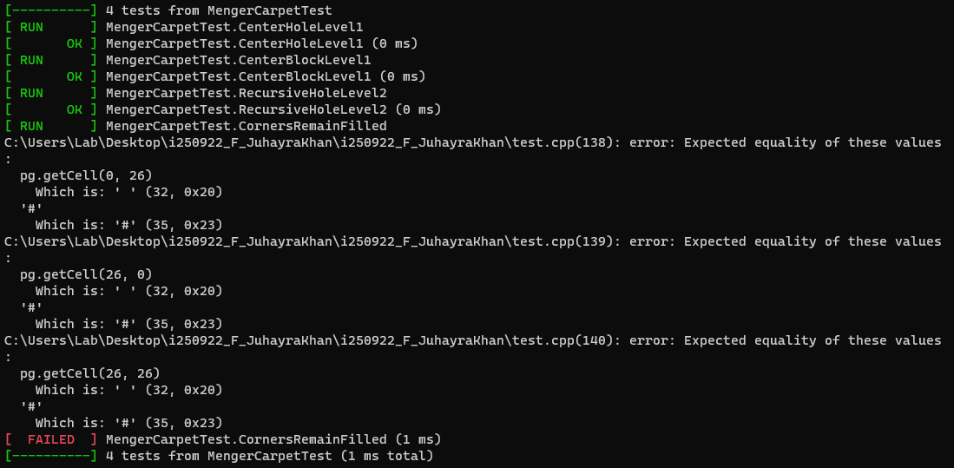
Q3
class AnagramFinder {
private: int i;
public:
int length(char* str) {
int i = 0;
while (str[i] != '\0') i++;
return i;
}
int* findAnagrams(char* s, char* p, int count) {
for (int i = 0; i < length(s); i++) {
}
return nullptr;
}
};
